Chemical Weathering
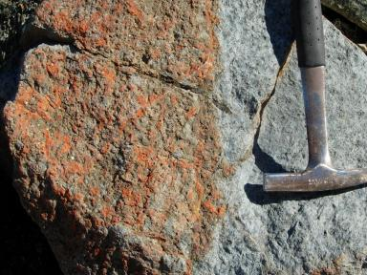

What Is Happening:
The rock above is being exposed to Chemical Weathering. Chemical Weathering is a process of breaking down rocks by chemically changing their makeup. Above, the rock is oxidizing, or rusting, causing the rock to weaken and eventually break apart.
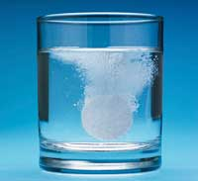
Steps:
1. Drop in a small chalk chip.
2. Pour vinegar to cover chalk.
3. Watch the reaction.

How does this relate to Geography?
- Landforms are constantly being reshaped by chemical weathering
- Chemical Weathering is occurring more often due to acid rain and pollutants.

Answer Questions for Chemical Weathering

Mechanical Weathering
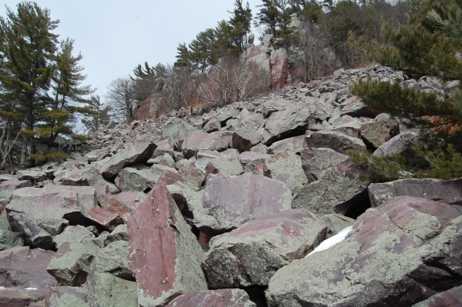

What Is Happening:
The rocks above are being broken apart due to Mechanical Weathering. Mechanical Weathering is the breaking of larger rocks into smaller rocks by force. This usually occurs at the surface of the earth when rocks fall, slide, or move in various ways.
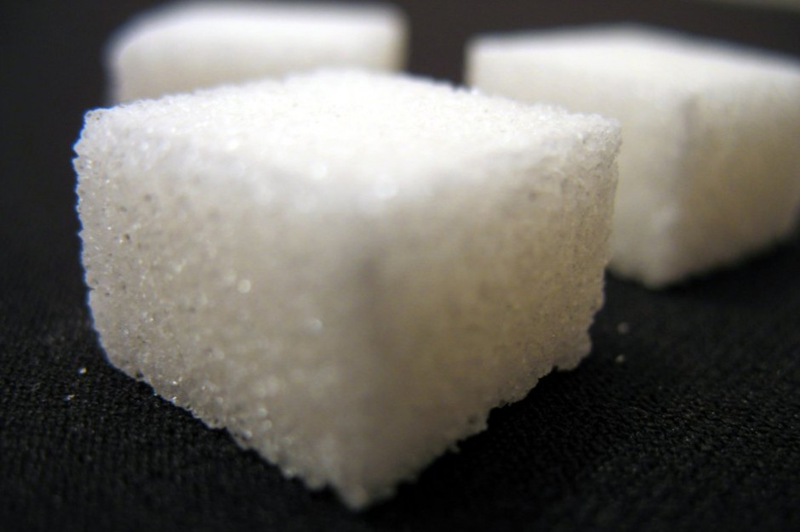
Steps:
1. Place 3 sugar cubes in the small
container. Tightly close lid.
2. Shake the container for 15 seconds.
3. Open and view the sugar cubes.

How does this relate to Geography?
- Landforms are constantly being reshaped by mechanical weathering
- All rock forms can be mechanically weathered and made smaller

Answer Questions for Mechanical Weathering
Wind Erosion
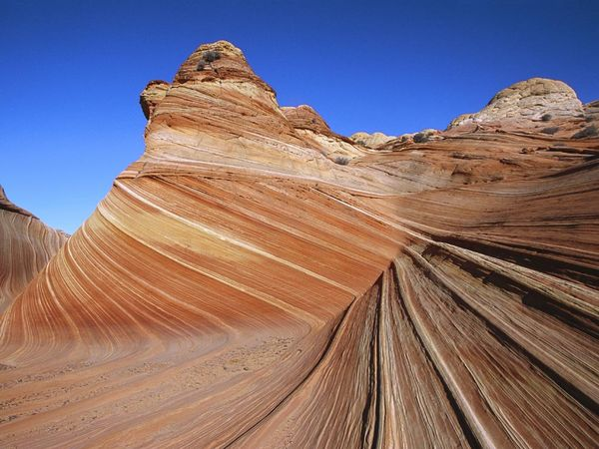

What Is Happening:
The rock above is being exposed to Wind Erosion. Wind Erosion refers to the damage of land as a result of wind removing soil from an area. Most often, wind erosion occurs on flat land in dry or sandy areas. Rock formations and sand dunes (where sand is blown away) are all the effects of wind erosion.
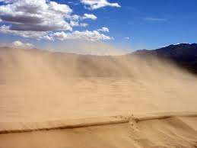
Steps:
1. Make sure all ‘formations’ are covered in sand.
2. Put on safety goggles.
3. Gently try to unbury the items by blowing sand away.

How does this relate to Geography?
- Landforms are constantly being reshaped by wind erosion
- Wind Erosion is a major cause of concern for farmers since the wind often removes the top layer of fertile soil from farmlands.

Answer Questions for Wind Erosion
Water Erosion
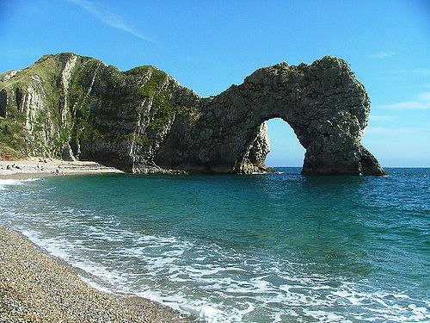

What Is Happening:
The rock above is being exposed to Water Erosion. Water Erosion is the moving and displacing of rock pieces due to water. Water erosion can be done quickly, or it can take thousands of years to reshape rocks.

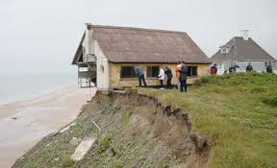
Steps:
1. Place one Sugar cube in the cup.
2. Strongly squirt water onto the cube for 20 seconds.
3. Watch what happens to the cube.

How does this relate to Geography?
- Water Erosion is can occur very quickly, and can be very dangerous.
- If you live near a water source, you need to be aware of how the water affects surrounding land.
- The Colorado River in the Grand Canyon has been removing rock for 100’s of years, and is constantly changing its shape.

Answer Questions for Water Erosion

Ice Wedging
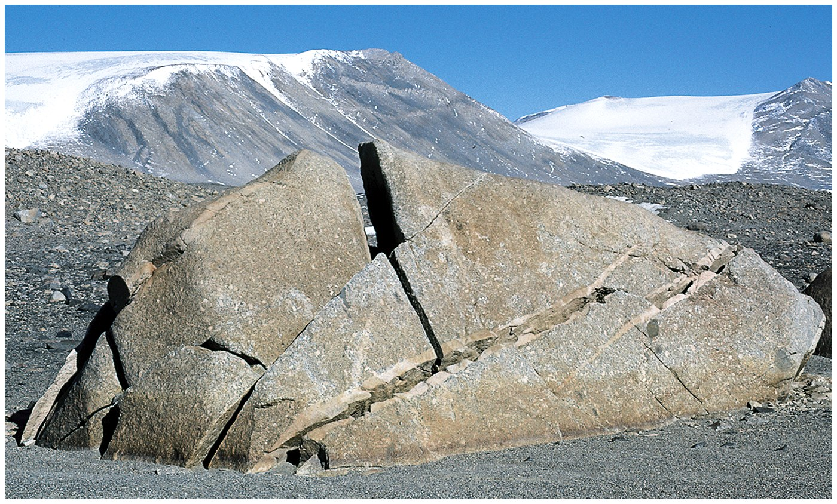

What Is Happening:
The rock above has been exposed to freezing temperatures and water. This process of constantly freezing, thawing, and refreezing is known as Ice Wedging. As water freezes, it expands. After expanding, the rock will break and cause wedges.
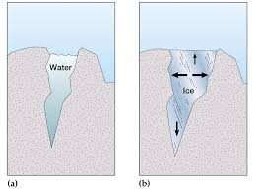
Steps:
1. Watch the video clip on the provided digital device.
2. Draw a quick illustration as to what is happening to the rock and ice.

How does this relate to Geography?
- Mountains and rock forms with a high elevation are constantly being exposed to ice wedging.
- This process is always changing the shapes of rocks and can cause major destruction to rock formations.

Answer Questions for Water Erosion

Name________________________________________Date__________Period_______
Notes over Weathering and Erosion
Weathering is ______________________________________________________________ __________________________________________________________________________.

Erosion is__________________________________________________________________ __________________________________________________________________________.
1. Chemical Weathering is a process__________________________________________ ___________________________________________________________________________.

Describe what happened to the chalk in Chemical Weathering. ___________________________________________________________________________

2. Mechanical Weathering_________________________________________________ ___________________________________________________________________________

Describe what happened to the sugar cubes after being shaken?
___________________________________________________________________________

3. Wind Erosion ____________________________________________________________ ___________________________________________________________________________

Describe how you were able to unbury the objects? ___________________________________________________________________________

4. Water Erosion ____________________________________________________________ ___________________________________________________________________________

Describe what happens to the sugar cube once water is applied?
___________________________________________________________________________

5. Ice Wedging. The process of _____________________________________________ _______________________________________________.____________________________

