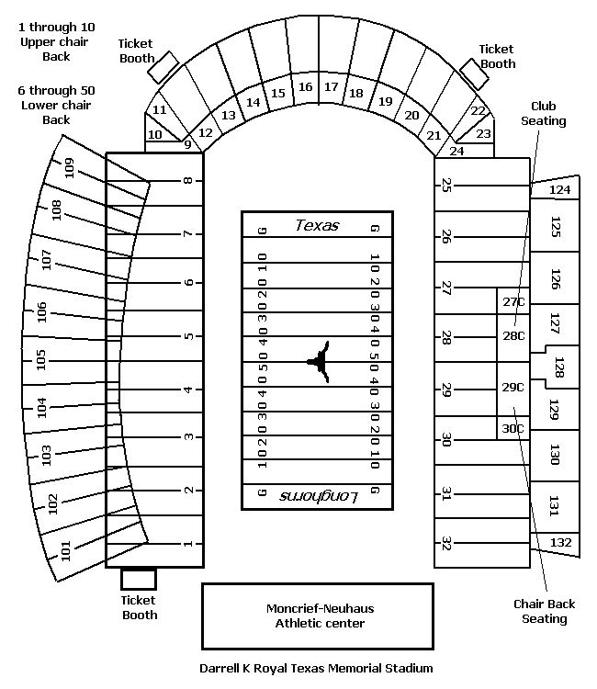
Types of Regions: Formal, Functional and Perceptual

