Plate Tectonics
Directions: While you read, annotate your readings. Annotating means to interact with the text. You will be highlighting important information while you read. Each time you highlight, you must also write down thoughts, questions, or summaries of your readings. Answer the questions and fill in the illustration after you have completed your annotating.

Did you ever wonder why the ground shakes during an earthquake? Have you ever asked yourself why some volcanoes are always active, while others only erupt once every thousands years? Believe it or not, scientists believe that earthquakes, volcanoes, and even tsunamis are all due to the favorite scientific theory of plate tectonics.

About fifty years ago, many scientists came up with an idea on why we experience earthquakes and volcanic activity. They also have concluded as to why some dinosaur fossils can be found on two continents that are far away from each other. The Theory of Plate Tectonics states that the second layer of earth, the lithosphere, is made up of large, broken up pieces. Seven or eight giant plates make up earth, with lots of minor plates between them. Tectonic plates are always moving and this is due to extreme convection heat under the earth’s crust, that is always in constant motion. The Plates rest on these heat currents. Sometimes, the plates move against or away from each other. Scientists have come up with the following names for these plate movements.

Divergent: When two tectonic plates pull away in opposite directions, it is called Divergent Plate Movement. This often happens on the oceanic crust, creating large trenches on the sea floor bed, along with earthquakes and tsunamis. When this happens, the gap between the plates exposes hot magma to icy salt water, resulting in large smoke plumes both under water and in the air above.

Convergent: This happens when two continental plates crash into each other. The earth’s crust will form a mountain range out of the compressed land. Mountain ranges can differ in size, due to the force or elapsed amount of time the two different plates have been pushing against each other. Convergent Plate Movement often results in earthquakes and can cause destruction.

Subduction: This type of plate movement is much like convergent plate boundaries, but in Subduction Plate Movement, you have an oceanic plate that collides with a continental plate. When this occurs, the oceanic plate is forced to move under the overlapping continental plate. Oceanic plates are much heavier, and will always move to the bottom, whereas continental plates are less dense and will move over the top of oceanic plates.

Transform: A lot of friction happens when two plates move against each other, or back and forth in a rubbing motion. As the plates grind in opposite directions, friction and pressure builds up until it is released. The plates will suddenly break and jerk apart, creating earthquakes and tsunamis. Transform Plates cause serious damage, even if new landforms are not created.

Our world is made up of different moving parts that are constantly crashing, pushing, brushing, and colliding into one another. The Plate Tectonic Theory helps explain how new landforms are made, where earthquakes come from, and other major questions about our planets crust and past.
Directions: Label the following types of plate movements.
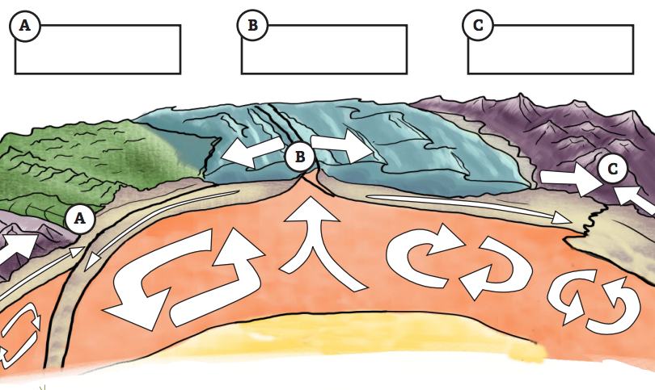
D.
D

Directions: Answer in complete sentences. Remember, all proper grammar rules apply.

1. Why is it that Plate Tectonics are presented as a theory by scientists?

2. During Subduction plate movement, what causes oceanic plates to be more dense than continental plates? (critical thinking)

3. Which plate movement does not always create new landforms? Why is this?

4. Divergent plates often result in what common landforms?

5. How were the Himalayan and Rocky Mountains created? Use an Atlas to compare the two ranges and compare them. Describe your findings. (critical thinking)

6. What causes all plates to move?

