Physical Processes Notebook Test
Directions: Answer the following questions on both your scantron and on your quiz. Use your social studies knowledge to answer each question. DO NOT LEAVE ANY BLANK!
1. _____ When thinking about the layers of the Earth, which layer is a solid metal spinning ball?
A. The Inner Core B. The Mantle
C. The Crust D. The Outer Core

2. _____ Which of the following is a true statement?
A. Earths plates only move away from each other, never towards each other.
B. Oceanic Crusts are heavier than continental crusts.
C. Earths plates are in the same spot that they were in millions of years ago.
D. The Earth is made up of one single solid plate.

Using the images below, answer questions 3-5
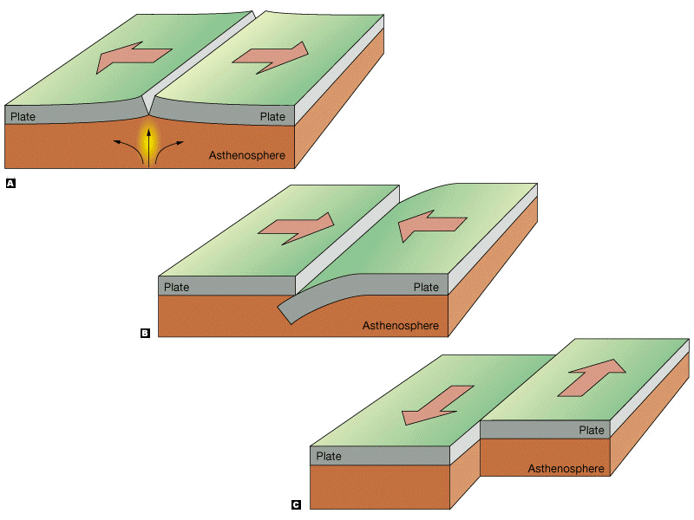
Image 3
Image 2
Image 1

3._____ Image one is a representation of which type of plate boundary movement?
A. Transform B. Divergent
C. Convergent D. Subvergent

4._____ Image 3 is a representation of which type of plate boundary movement?
A. Transform B. Divergent
C. Convergent D. Subvergent

5._____When two plates come together, like image 2, which type of landform is most likely to be created?
A. Valley B. Trench
C. Desert D. Mountains

6._____ Hydrogen, Carbon, and Nitrogen would be found in which sphere of the Earth?
A. Atmosphere B. Hydrosphere
C. Lithosphere D. Biosphere

7._____ Which of earths spheres is home to living organisms?
A. Atmosphere B. Hydrosphere
C. Lithosphere D. Biosphere

8._____ What would most likely be found in the Lithosphere?
A. Oxygen and Natural Gases
B. Mountains and Earth’s Crust
C. Oceans, streams, and lakes
D. Animals, people, and plants

9. _____Which of the following elements would not be part of the atmosphere?
A. Rain B. The Sun’s Rays
C. Oxygen D. Carbon Gas

10._____What landform has a high elevation and is frozen?
A. Mountain B. Volcano
C. Glacier D. Canyon

11. _____Which of the following has the lowest elevation?
A. Plateau B. Island
C. Plains D. Valley

12. _____ What results when plates move and shift?
A. The creation of new landforms
B. Earthquakes
C. Volcanic eruptions
D. All of the above

13._____ According to the Theory of Pangea, most scientist’s hypothesis that …
A. Earths plates are moving back together to their original positions
B. Earths plates have never moved in the past.
C. Earths plates did move in the past, but are now stationary and will not continue to move.
D. The earth’s plates are in motion, and over a long period of time have moved around, creating new landforms and major natural disasters.

14. Which of the following is not a many factor that influences latitude and temperature?
A. Ocean currents
B. Altitude
C. Perceptual regions
D. Distance from the large bodies of water

15. The continent of Africa is home to which climate zones? (May required more than one answer)
A. Cold
B. Temperate
C. Warm
D. Tropical

16. Fill in the blank with the appropriate information missing.

Climate Zone | Latitude | Angel of Sun’s Rays
A. Temperate | B. 23.5° to 66.5° North and 23.5° to 66.5° South | C. ___________________________  ___________________________

A. Direct or nearly all year round
B. More direct sun in the summer, less direct in the winter
C. Less direct all year round
D. Due to the earth’s axis, it is cold all year round

17. Match the following descriptions to the word bank.
Word Bank
A. Volcano
B. Earthquake
C. Hurricane
D. Drought
17._____ Magma, Chamber, Pressure
18._____ Violent Winds, Tropical Storms
19._____ Erosion, Fire Spread, Failure Crops
20._____ Tectonic Plates, Friction, Transform

Extra Credit (5 point) – Answer only one of the following question using complete sentences and using details. A minimum of 5 sentences is required to receive full credit.

1. What is the Ring of Fire and explain how does it affect people and Earth?

2. Why do people migrate to other places? Be specific and use examples.

