Hinduism

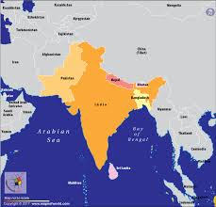
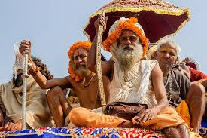
As one of the oldest religions in the world, Hinduism has no identifiable founder because it is a religion that evolved and developed through the ages from the spiritual, religious, and social practices of the people of the Indian subcontinent. Unlike most other religions, Hindu tradition has no single founder and or book. People are allowed to choose their own path for enlightenment; which ever suits a person most in terms of his or her current position, abilities, and needs. These paths are guided by a guru (spiritual leader), or a book of teachings, but can also be guided by tradition or purely conscience.

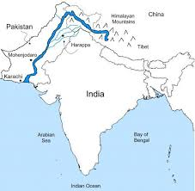
The word Hindu comes from the Sanskrit name for the river Indus. Most likely, the people from the Middle East used the term first to indicate the people who lived on the eastern side of the Indus River. Hindus use Sanatana Dharma, or the ‘eternal universal tradition of righteousness and duty’ to describe their spiritual and social practices. According to many, Hinduism appeared around 1500BC, but Hindus and some other scholars believe that is the religion is much older than that even.
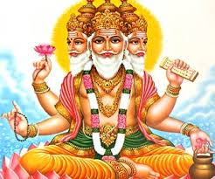
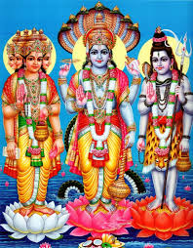
Hindus consider Brahma, or Isvara the ultimate reality (highest god). There are hundreds of gods and goddesses (devas or devis) in Hinduism, and each is seen as the personification of an aspect of Brahma. The three main gods representing the Hindu Trinity are Vishnu, the force for preservation; Brahma, the creator; Siva, the destructive force. Each god also has an accompanying goddess, and they are Lakshmi, representing wealth and prosperity; Saraswati, representing knowledge, and Shakti and Durga, representing creative power.

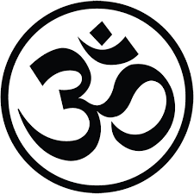
Hindus believe in karma. Karma is the law of action and effect, which states that what you do in this mundane life has either a positive or negative consequence n the realms of ultimate reality, which in turn affects your earthly existence. Along with karma, Hindus believe in re-birth or reincarnation. The life goal for a Hindu is to escape the worldly cycle of karma and rebirth by allowing his or her soul to become one with Brahma- the One that is All. Moksha is the term for this final release from mundane existence. Sometimes Hindus refer to this state as nirvana, but nirvana started as a Buddhist term. Hindus believe that worldly objects distract and prevent a person from attaining oneness with Brahman. A deeper mean of Moksha is to free oneself from all the human emotions (greed, anger, hatred) and attachments, which are causes of pain and suffering.

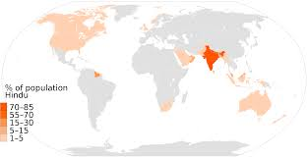
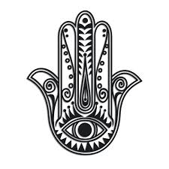
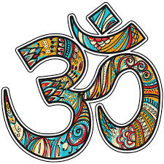
The Primary Hindu religious books are called the Vedas, which means ‘knowledge’ in ancient Hindu, and are the oldest texts known to humans. They also believe the Vedas contain universal truth. There are four basic Vedic books. The Rigveda is the most important book and contains mantras (hymns to the gods). These were composed thousands of years ago and were memorized, chanted, and passed down orally from one generation to the next before being written down. The other Vedic books are Yajur-veda, Sama-veda, and Atharva-veda. There are also hundreds of others works and books within the Hindu religion that focus on specific teachings or gurus.

