Buddhism
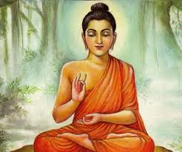
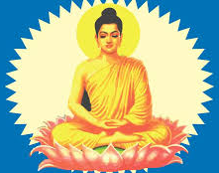
Buddhism is a belief system based on the life and teachings of Siddhartha Gautama, known as the Buddha. Gautama was a prince who lived in India from 563 to 483 B.C. According to legend, Gautama led a life of luxury but was also sheltered in his palace. One day his comfortable life was shattered when he saw a man who was very sick, one who was weak and feeble, and one who was dead. Gautama realized that life was an endless cycle of pain, and the only way to escape it was by seeking wisdom. So, he left the palace ad for six years tried to find wisdom through harsh discipline and suffering. For days at a time he ate only a single grain of rice each day. Despite his efforts, he felt only pain, not wisdom and insight about life. Finally, at the age of 35, after meditating deeply for many days, in the shade of a tree, he suddenly felt that the truth about life became clear to him. Thereafter, he was known as the Buddha, or the ‘enlightened one’.

Many of the important foundations of Buddhism were state in a sermon that Buddha gave shortly after his meditative experience. Buddha taught these four main ideas, known as the Four Noble Truths.

- First Noble Truth: Suffering and sorrow are part of life. The Buddha believed people everywhere were subject to pain, sickness, and death.

- Second Noble Truth: The cause of suffering and sorrow is people’s self-centered desires. People seek pleasure that cannot last and leads only to more suffering. If people did not want wealth, power, pleasure, and fame, they would not be disappointed and unhappy when they do not have things.

- Third Noble Truth: The way to escape suffering is to overcome desires and reach a state of “not wanting”.

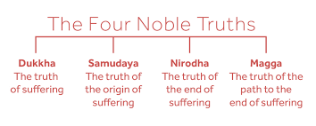
- Fourth Noble Truth: People can overcome their desires and reach a state of enlightenment (release from the pain and selfishness), or nirvana, by following the Middle Path. The Middle Path involves leading an ethical (morally correct), compassionate life, in which one meditates and participates in rituals.
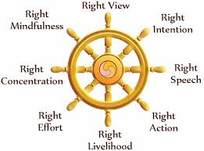
The Middle Path offered people practical guideline for how to end suffering. The guidelines were known as the Eightfold Path, which those who sought enlightenment had to master one step at a time, like ascending stairs. According to the Buddha, the steps of the Eightfold Path included a right to: Knowledge, purpose, speech, action, living, effort, mindfulness and meditation. By following the Eightfold Path, anyone could attain nirvana and escape suffering. In addition, the Buddha believed in a cycle of rebirth-that individuals were reincarnated (reborn in another body without memories from their previous life) and subjected to lifetimes of suffering until they reach enlightenment.
In the years after the Buddha’s death, there were two important developments in Buddhism. First, Buddhism evolved from a philosophy of life into a religion. In many branches of Buddhism, the Buddha is now worshiped as a god and Buddhists pray to Buddha, asking him to help them reach enlightenment. Second, travelers and missionaries spread Buddhism and it became a major religion throughout East Asia. Buddhism was brought to China in A.D. 200 by monks and traders who traded all over India to Central Asia and then to China. In the centuries that followed, Buddhism grew in popularity until its influence rivaled that of the major Chinese belief systems of Confucianism and Daoism.

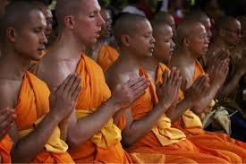
Despite efforts starting in 1949 by the communist government to prevent the spread of Buddhism- such as arresting Buddhist monks and priests and closing Buddhist monasteries and temples- it continues to be an important religion in China. In the mid 1970’s the Chinese government allowed a limited revival of Buddhist institutions. In modern times, Buddhist rituals continue to be followed in many important ceremonies.
